  ______________________  Highlights:  - A BioCompute object (BCO) is a schema to represent in-silico pipelines  - BCO is an IEEE standard and is used for communicating bioinformatic analysis and data provenance  - BCOs can promote interoperability and bioinformatics protocol verification  - BCO development is community-based  - BCOs are compatible with workflow languages (e.g. NextFlow, CWL, WDL)  _______________________  Contact:  https://docs.biocomputeobject.org/contact/  IEEE Standard:  https://standards.ieee.org/ieee/2791/7337/  FAQs: https://wiki.biocomputeobject.org/index.php?title=FAQs | BioCompute Objects – A Framework For Communicating Bioinformatics Pipelines  Issues associated with data analysis  Some of the main issues associated with data analysis are unpredictability, interoperability, and communication. Everyone understands that a physical experiment (physics, chemistry, biology, etc.) becomes more unpredictable with more variables. For this reason, scientists will record every variable in the protocol. An in-silico experiment is no different. Computational biology algorithms can be just as complicated as a real-world physical experiment, but this fact is often overlooked.  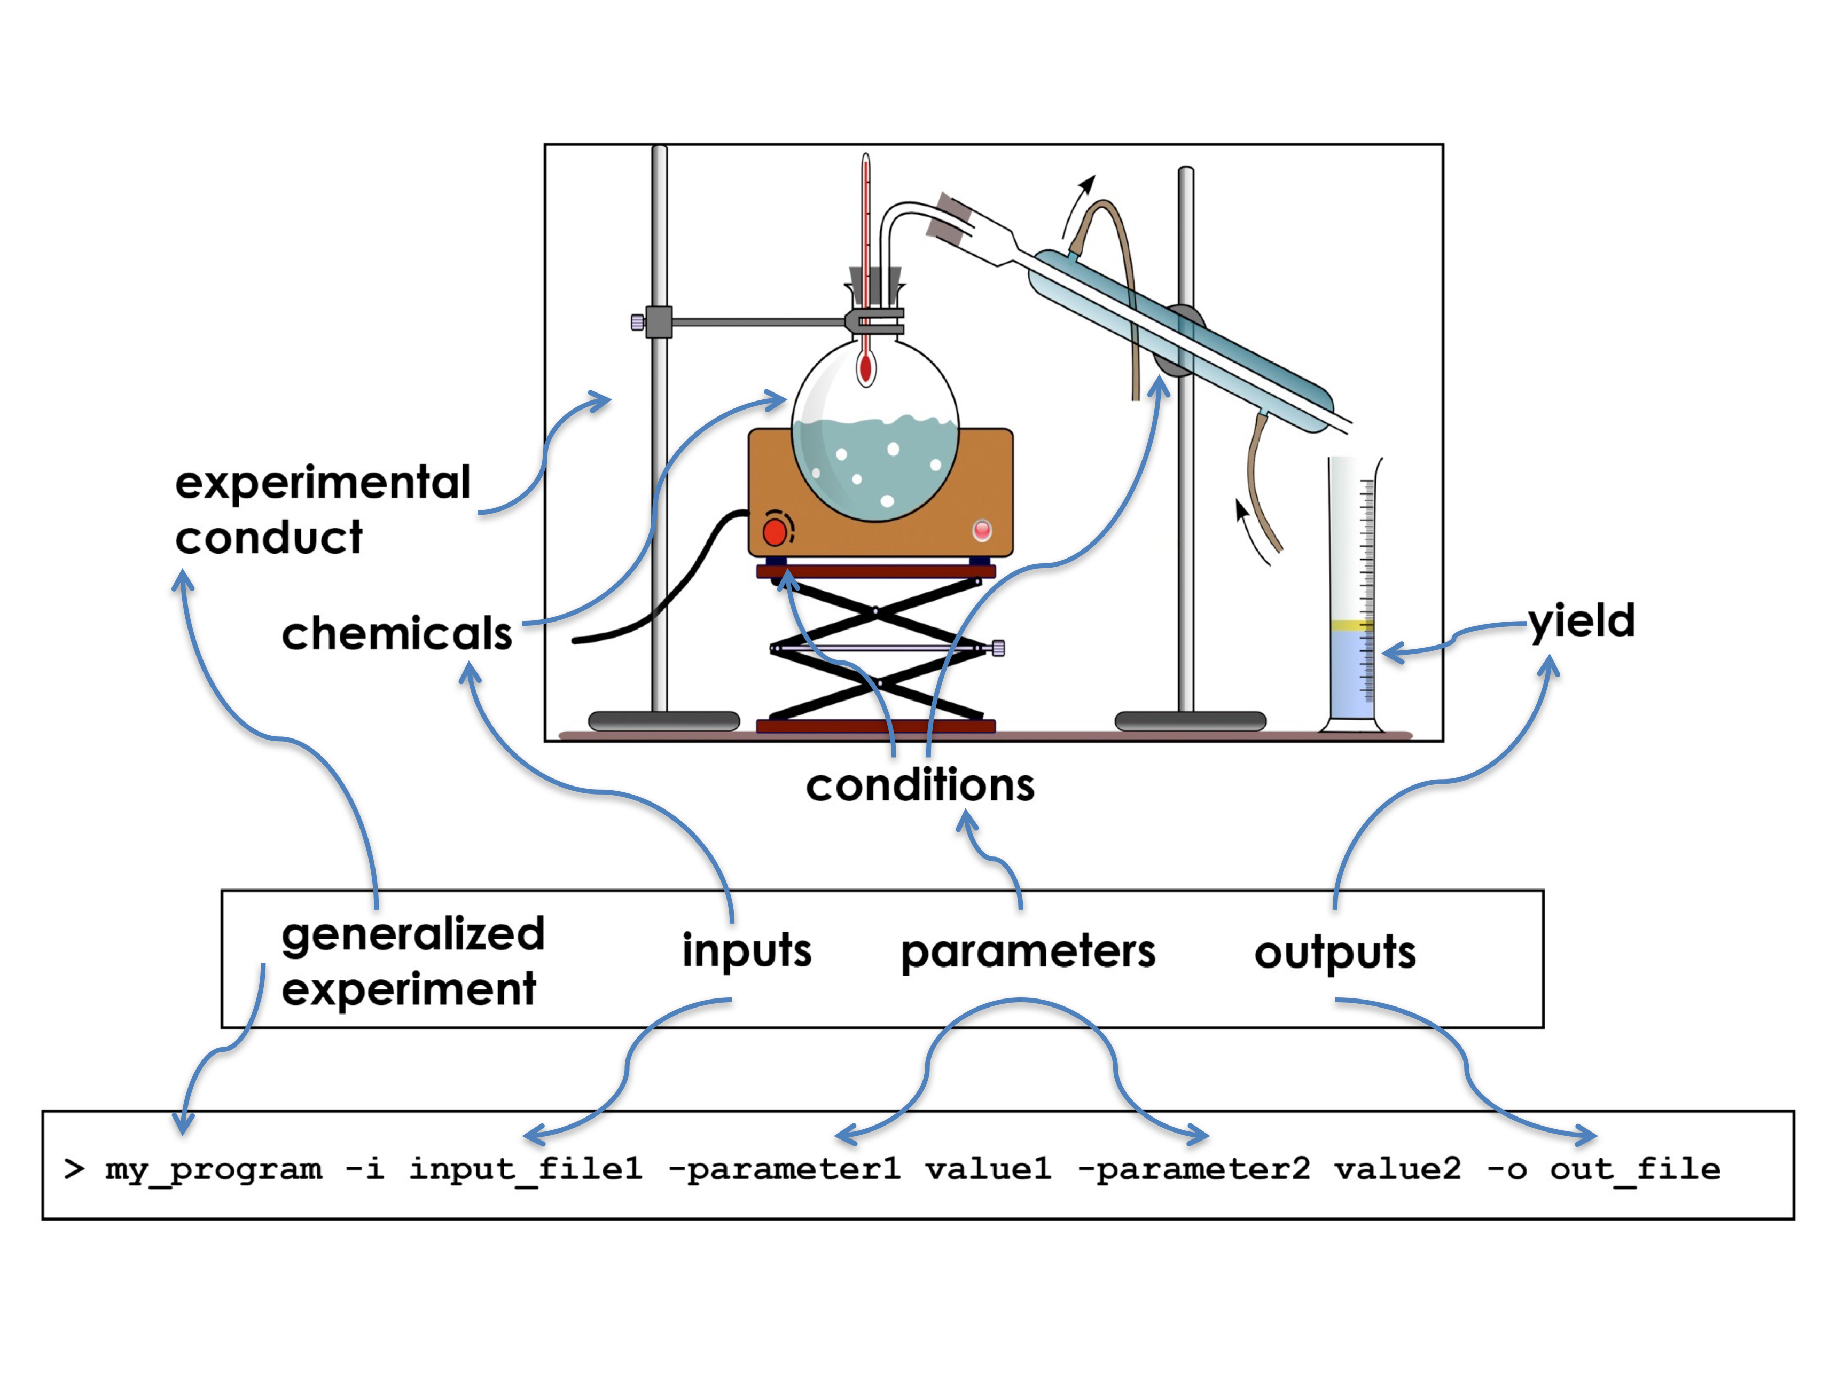
BCO Structure  BioCompute data types are defined as aggregates of critical fields organized into eight domains:  - identification and provenance information,  - descriptive domain,  - input/output domain,  - parametric domain,  - execution domain,  - usability domain,  - error domain, and  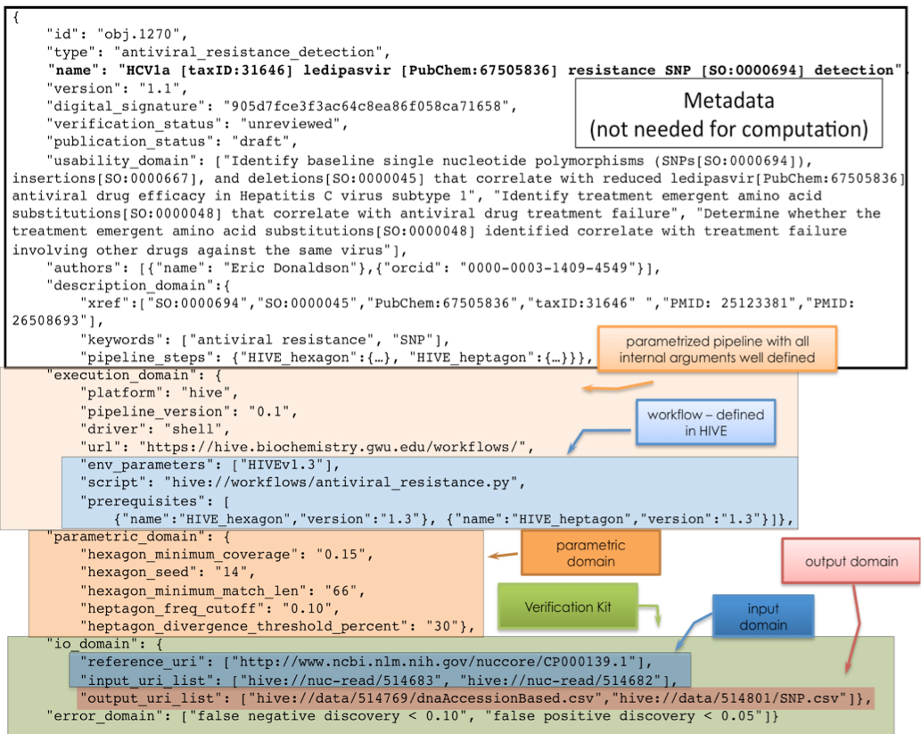  - Extension domain  Potential use-cases  - A pharmaceutical company is planning on submitting NGS analysis results to the FDA for regulatory review. They can create BCOs that are both human and machine-readable to potentially speed up review  - Vendor/researcher can create BCOs to document and share their pipelines in a standardized format so that they can be evaluated by SMEs or SOP documentation.  - Bioinformatics software platform developers can create BCOs to better showcase the utility of compatibility with other platforms and agencies. | BioCompute Object Project Mission  Whereas NCBI’s BioSample furnishes descriptive details of biological samples underlying experimental data, BioCompute encapsulates information on the computational pipelines employed to analyze data and derive insights. Our mission is two-fold. The first part is to develop a community of stakeholders to create a framework that allows standardized descriptive information on bioinformatics pipelines. The second part is to develop tools for the creation, storage, and distribution of BioCompute Objects (BCOs). BCOs can be used to describe computational methods in publications, laboratory notebooks, FDA submissions, and more.  BCO Construction  There are several ways to construct a BCO: Use the form-based BCO creation at biocomputeobject.org; Download the Docker container and deploy the BCO ecosystem at your organization (including the form-based editor); Use one of the several BCO-compatible bioinformatics platforms (e.g. DNAnexus, Seven Bridges (Velsera), Galaxy, HIVE).  